PROJECT WORK

SUBMITTED BY – KUSHAGRA TRIVEDI

SECTION:DS

UNIVERSITY ROLL NO.-2015079

ClASS ROLL NO. -40

DATASET-WINE+QUALITY+DATASET(1).CSV.

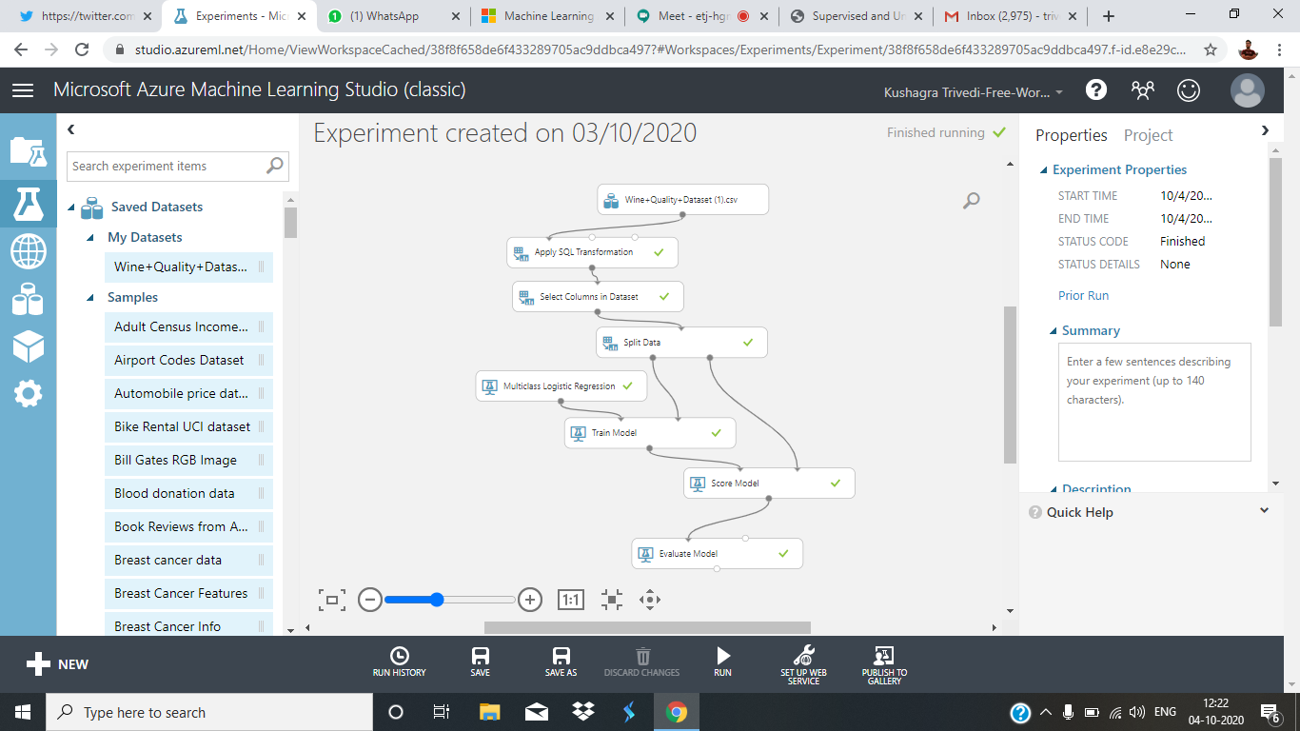

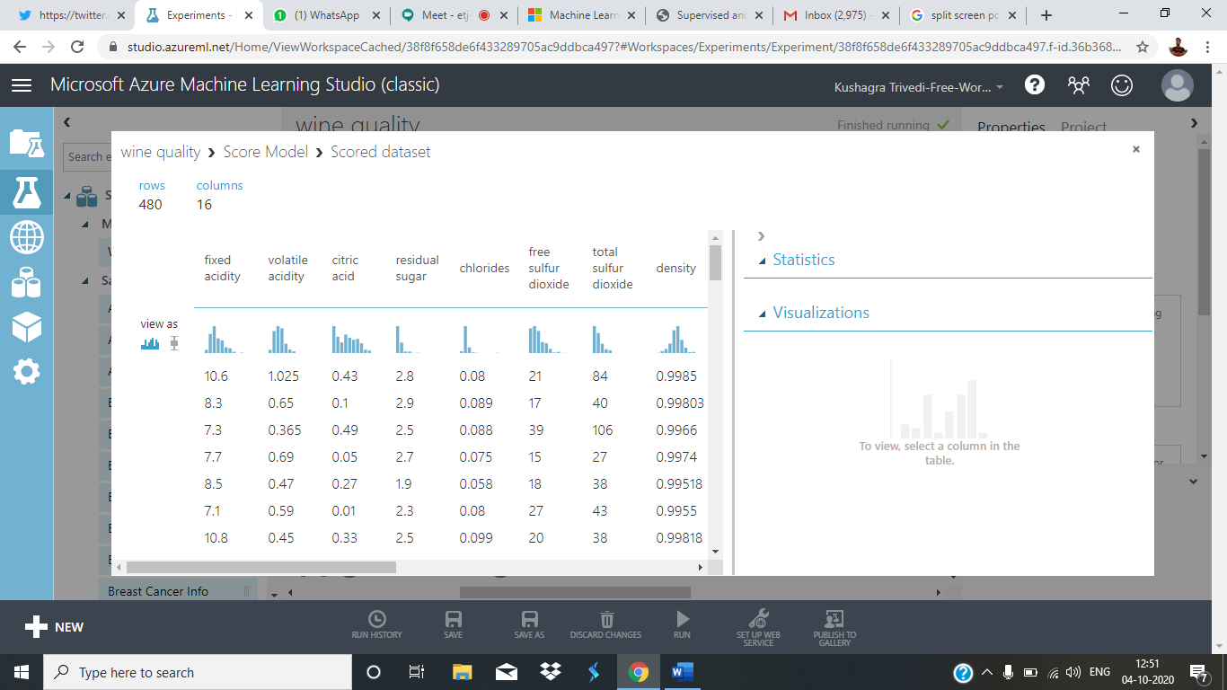

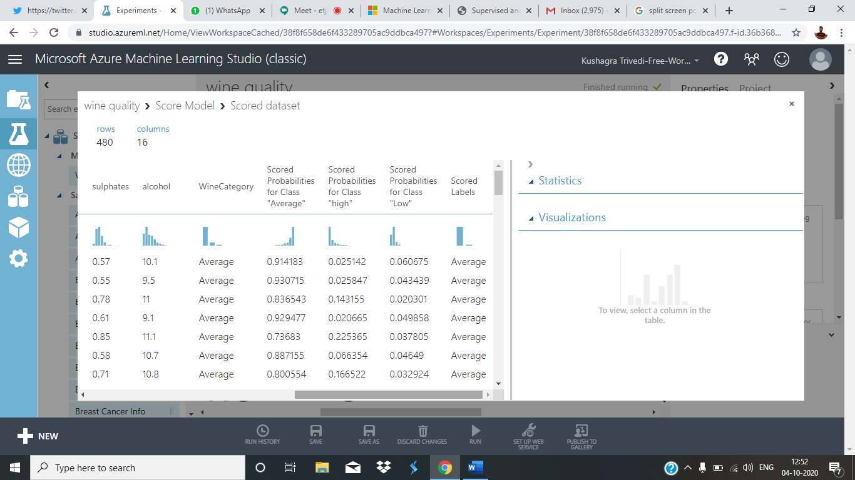

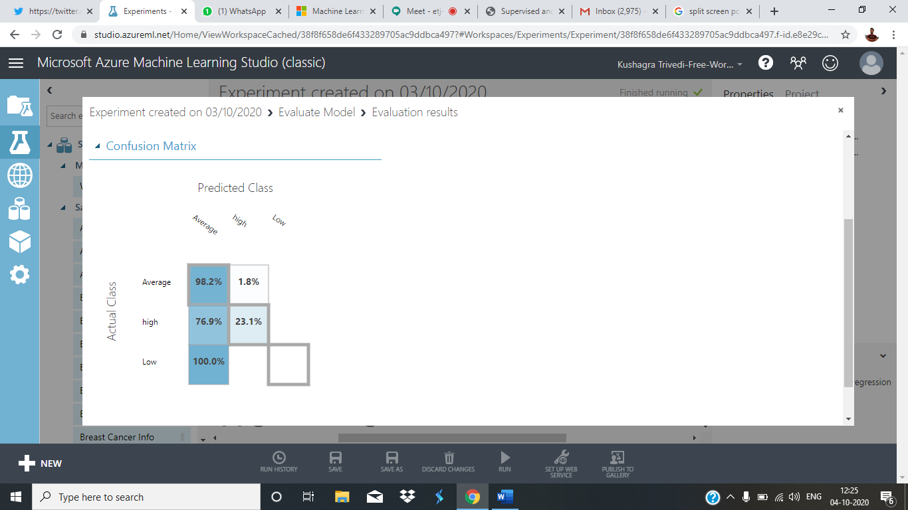

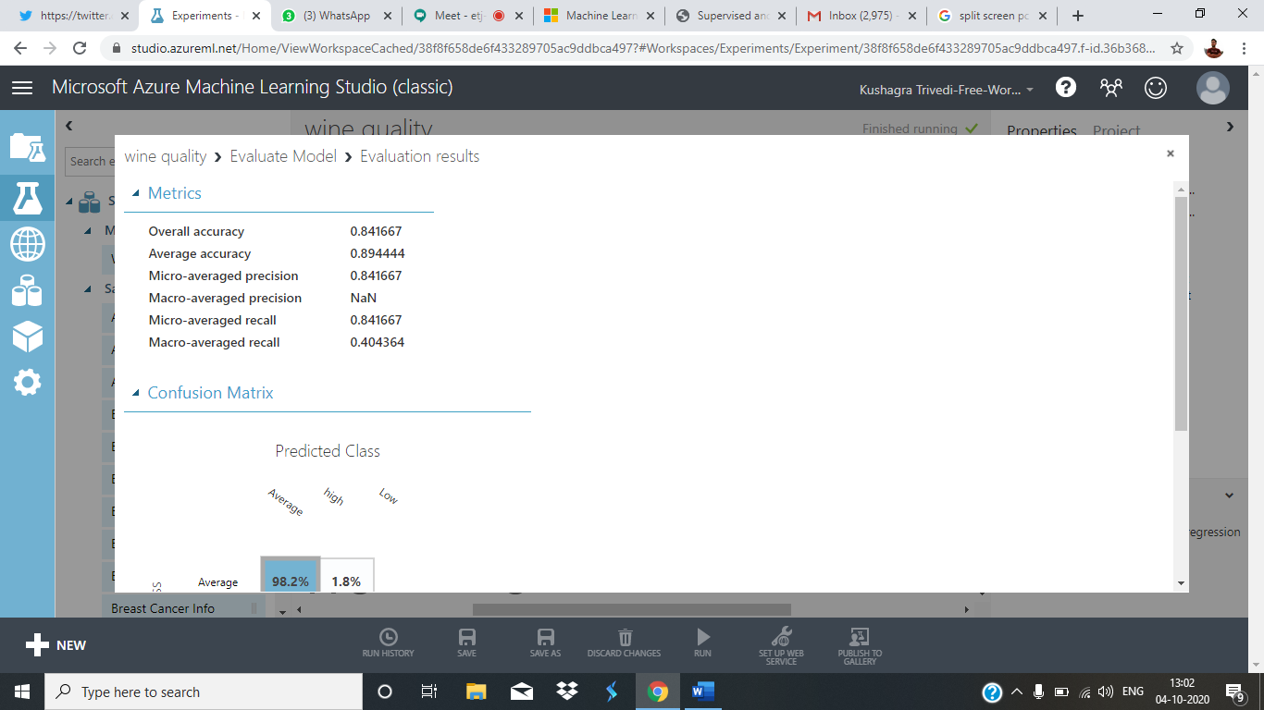

THANK YOU SIR.